CS 255 System Design Document Template

This template lays out all the different sections that you need to complete for Project Two. Each section has guidance to prompt your thinking. You will need to continually reference the interview transcript as you work to make sure that you are addressing your client’s needs. There is no required length for the final document. Instead the goal is to complete each section based on what your client’s needs are. Remove this note when you are finished, and replace all bracketed text with the relevant information.

UML Diagrams

UML Use Case Diagram
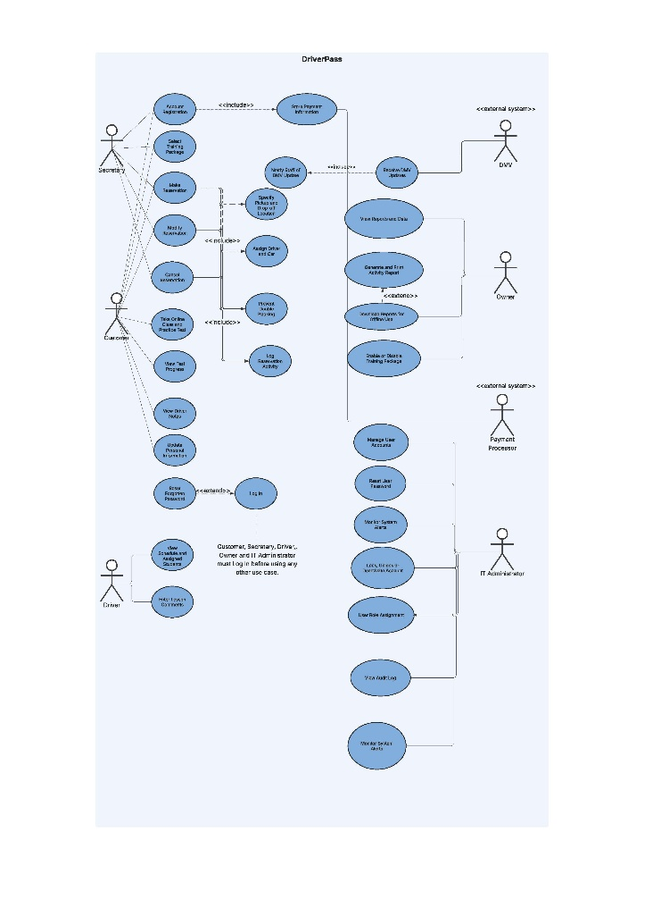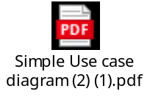

UML Activity Diagrams
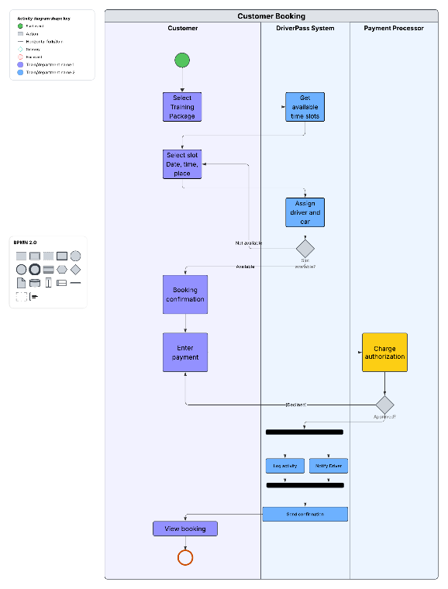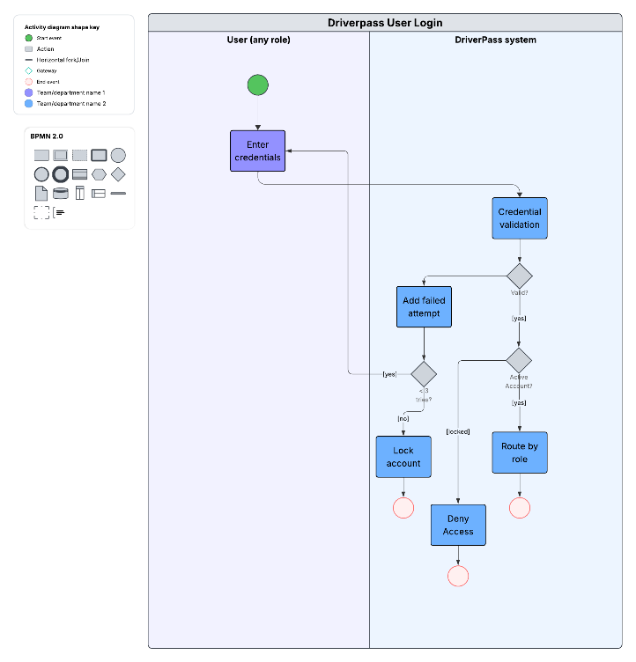



UML Sequence Diagram
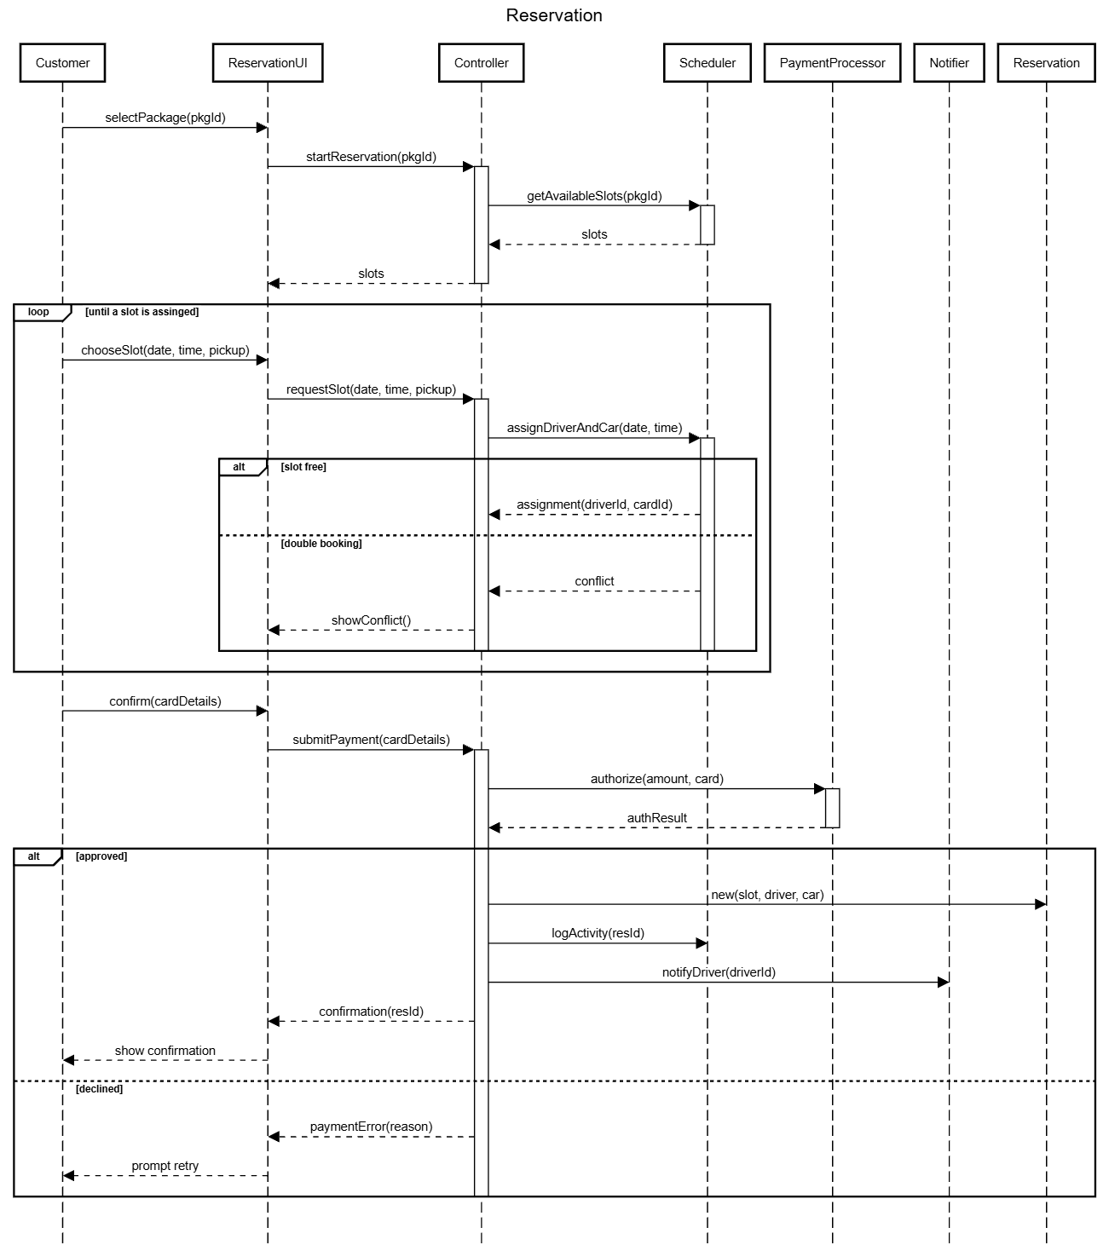

UML Class Diagram
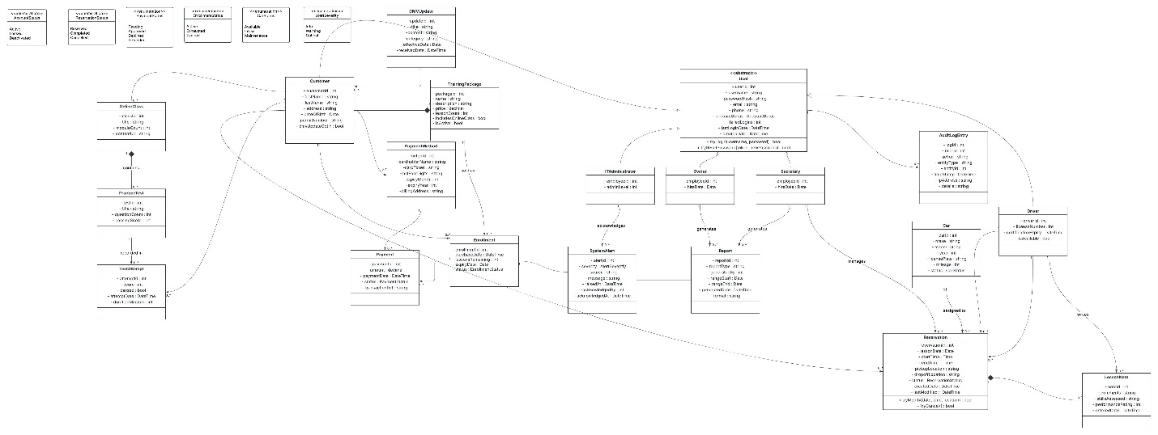


Technical Requirements
The DriverPass system will be deployed as a web-based, three-tier application hosted in a single cloud region, as required by the non-functional requirement that the system be cloud-based, with backups and infrastructure security handled offsite rather than by DriverPass staff. On the client side, no specialized hardware is required; users need only a current version of a standards-compliant browser like Google Chrome, Microsoft Edge, etc. On a desktop, tablet, or phone, the interface is responsive down to roughly 360 pixels to meet the multi-device requirement. On the server side, the system requires at minimum two stateless application instances of approximately 2 vCPU and 4 GB RAM each, placed behind a load balancer and web application firewall that terminates TLS 1.2 or higher and applies rate limiting to the login endpoint. The application tier must be stateless so that session data lives in the shared data store rather than instance memory, since consecutive requests from the same user may be routed to different instances. Persistence requires a managed relational database with roughly 2 vCPU, 8GB RAM, and 100 GB of SSD storage, configured with a synchronous standby, plus about 50 GB of object storage for nightly backups and generated report files. The sizing is modest because the business scale is modest. You have ten cars with dedicated drivers running two-hour lessons, which means about 50 lessons per day. The stated 99.5 percent uptime target allows about 3.6 hours of monthly downtime.

Software and tooling requirements follow from the functional requirements. The back end requires a server-side framework with role-based authorization, running on a Linux or Windows Server image behind nginx or IIS. Three external integrations are mandatory. A PCI-DSS-compliant payment processor using client-side tokenization so that raw card data never reaches the DriverPass servers, leaving only a token and the last four digits in the database; a scheduled HTTPS pull from the DMV feed with retry, and schema version validation that raises an administrator alert on any parsing failure or stale data; and a mailing provider that delivers single-use password reset links and critical system alerts. Security infrastructure should include enforced HTTPS, encryption at rest for the database and backups, bcrypt password hashing, multi-factor authentication for all staff roles, and a secret store for credentials and API keys. Development should have Git-based version control, separate development, staging, and production environments with no production data in lower tiers.

